MB913

STM32-DISCOVERY

PCB Manufacturing Specification

Modification History
NOTE: Change bars at the edge of each page show changes between revisions of document.
Please note that Section 1 Modification History on page 2 should only be used as a guide to the document changes and the whole document should be referenced for complete changes.

Revision A
Created on 27/01/2010 by mr chen

Contents
1 Modification History 2
2 Contents 3
3 PCB Manufacturing Specifications 4
3.1 Stack up description 4
3.2 PCB overview 4
4 PCB marking 5
5 PCB milling diagram 5
6 PCB Drill schedule 5

PCB Manufacturing Specifications

Stack up description
Stack up is a follow:
Artwork 1: Top-silkscreen
Artwork 2: Top-solder-mask
Artwork 3: Top-paste-mask
Artwork 4: Top-layer
Artwork 5: Bottom-layer
Artwork 6: Bottom-paste-mask
Artwork 7: Bottom-solder-mask
Artwork 8: Bottom-silkscreen
Artwork 9: Drill-drawing-layer1-2
Artwork 10: NC-drill
Describe here the pcb build up with all the layers (external copper, core, pre preg, inner copper) , their thickness and the material

PCB overview
Number of layers | 2
Minimum track width | 152.4µm
Minimum spacing between tracks/pads | 152.4µm
Minimum hole size, mechanical and laser drill | mechanical drill: 406.4 µm;
Bare board test required (Single or Double sided) | Double sided
Silkscreen colour | White
Does the board have surface mount components | Top surfaces only
Plating type: Chemical Gold plating (See note), Selective Tin/lead, selective NIAu, Tin HAL, Chemical Tin | Immersion Gold
Legislation | PCB must comply RoHs legislation
Solder resist type process (photo imageable, LDI), colour | Photo imageable,Green
PCB material FR4 HTG xxx | FR4 HTG 175
Copper weight (Outer) | 1oz
Copper weight (Inner) | 1oz
PCB Thickness and tolerence | 1.6mm +/- 0.15 mm
PCB size  Panel size (refer to file pcb panel.gbr or .dxf) | 43.18mm *84.6 mm  215.90mm * 84.6mm
Information: Initial PCB manufacturer name | Chinafastprint
Controlled impedance lines (value and layers) | e.g. 45 ohm between layer 1-2  e.g. 50 ohm between layer 7-8
controlled impedance line sample required
Notes
1 The following standard PCB manufacturing edits are accepted: teardrop addition, non-functional pad removal, addition of copper in waste areas
2 If gold plating required use selected nickel gold plating, a flash of nickel at 5 micron and gold at 0.1micron.
Gold plating is also called Immersion Gold
3 Silkscreen clipping is acceptable as long as no pin 1 markers are removed.
4 Solder mask removals around vias drill holes are recommended. solder mask pads for the vias as follow: hole size+0.1mm
5 the initial PCB manufacturer indicates can eventually be used for manufacturing the series; this saves the cost of the tooling. This is to be balanced with the volume and unit cost capabilities.
6 List all the controlled impedance lines with the required impedance (single line or differential lines). E.g. USB lines between IC4 pin 3 and IC14 pin 15 & IC4 pin 4 and IC14 pin 16, differential 90 ohm
7 If “controlled impedance line sample required” answer is YES, the pcb manufacturer must manufacture a sample for each board produced to allow the impedance line measurement

PCB marking
The PCB manufacturer must indicate clearly his name. (An abbreviation is admitted)
The PCB manufacturer must indicate the manufacturing data code (e.g. 0641 for week 41 year 2006)
No Rohs marking is required unless specified. Need

PCB milling diagram
Please insert diagram or refer to PCB milling or drilling drawing (gerber file, ODB++ file …)
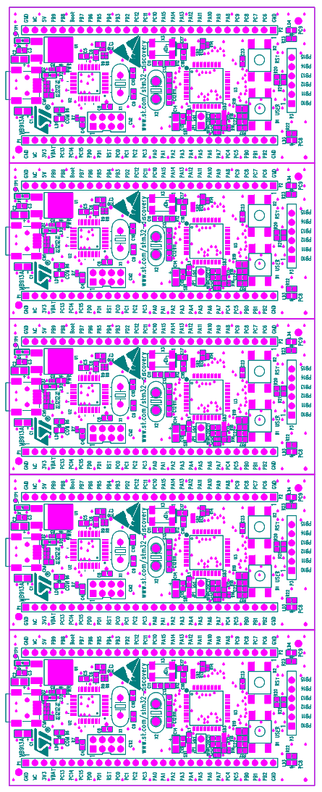

PCB Drill schedule
Please insert table or refer to PCB Drill schedule (gerber file, ODB++ file …)
Refer Gerber file: drill-drawing-layer1-2.pho & drill-drawing-layer1-2.rep

